Objective
Simulate the magnetic field of a Cyclotron
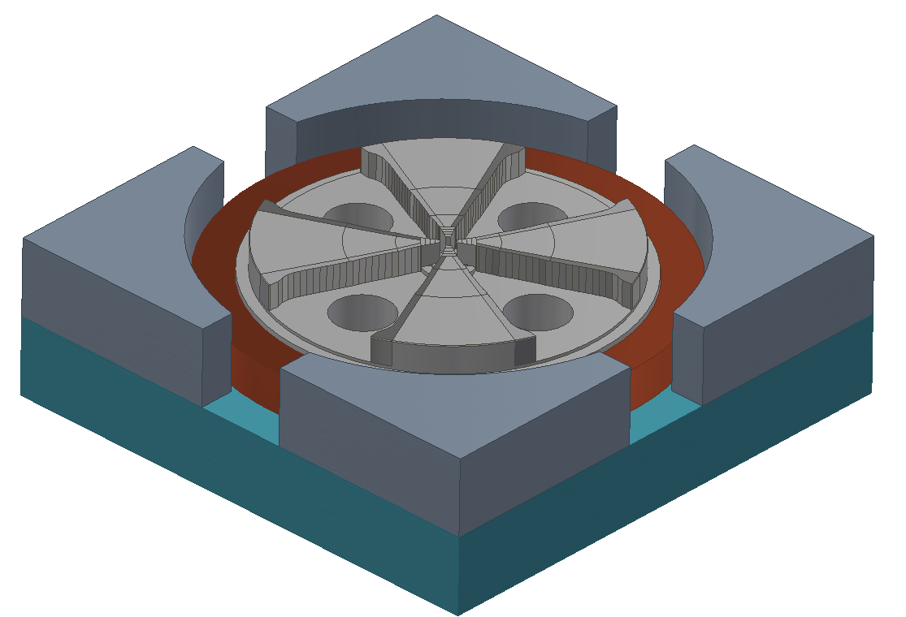
Bottom Half of Cyclotron

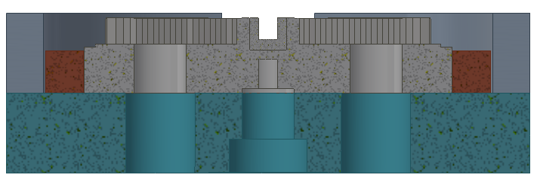
Cross Section of bottom half

COMSOL Set-Up
1/8 Symmetry
Definitions
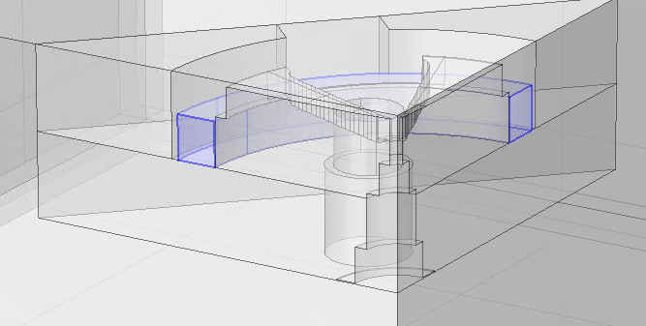
Coil

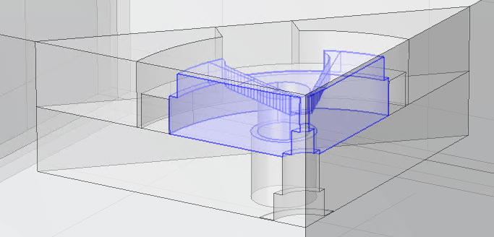
Inner Pole

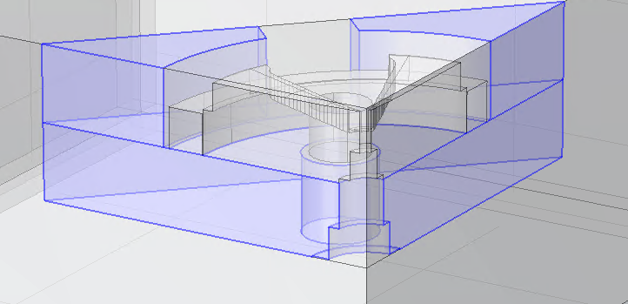
Magnet Frame
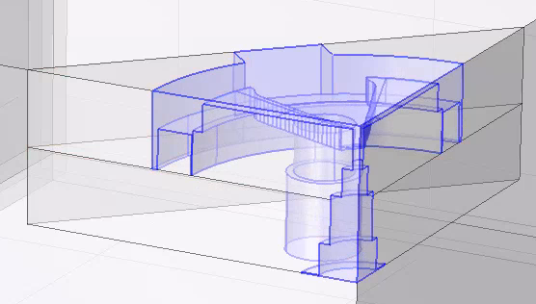
Air Domain – Near Field

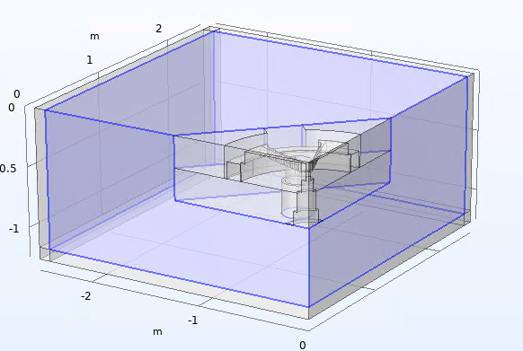
Air Domain – Far field
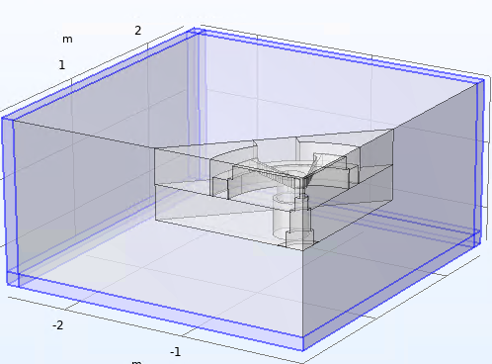
Infinite element Domain

Physics
Coil
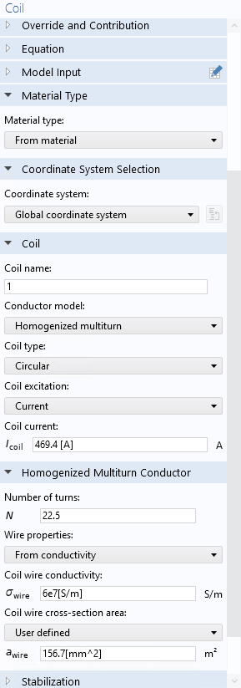

Magnet Frame & Pole

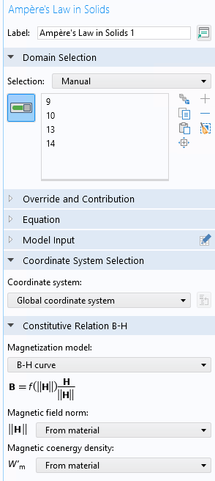

Symmetry 1
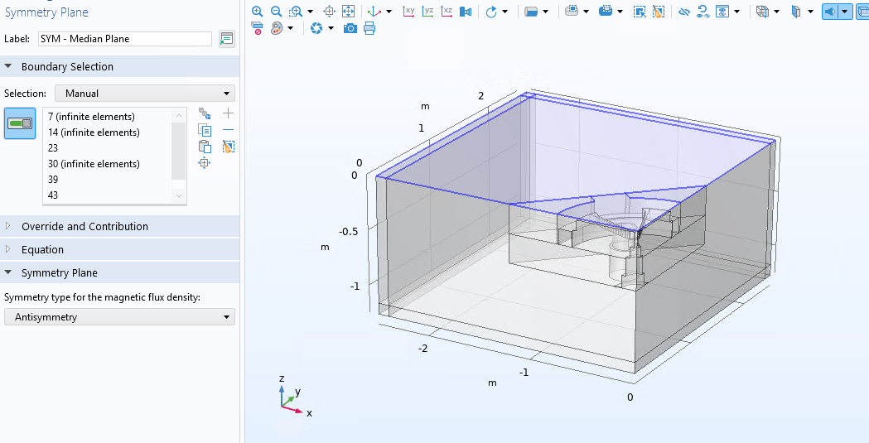

Symmetry 2

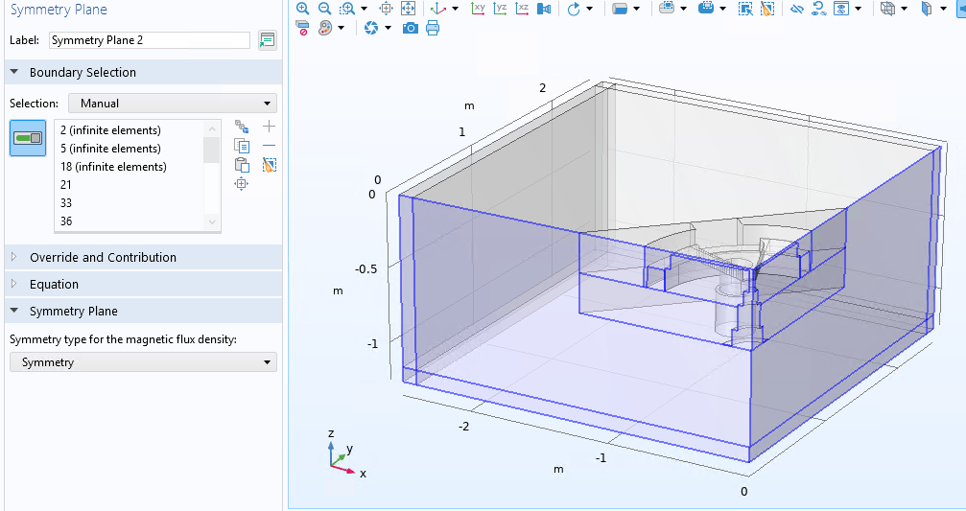

Mesh
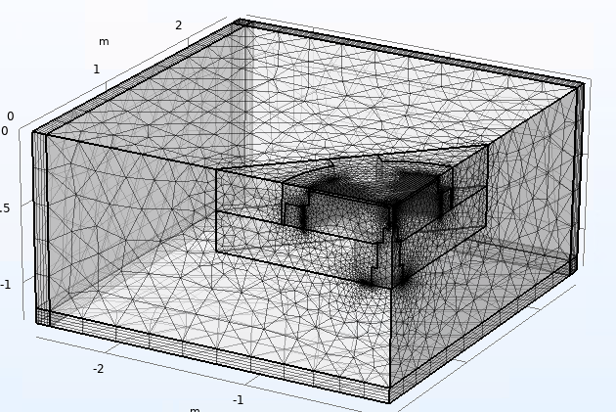

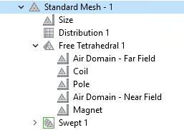

Mesh size of each domain was adjusted to remove any warnings

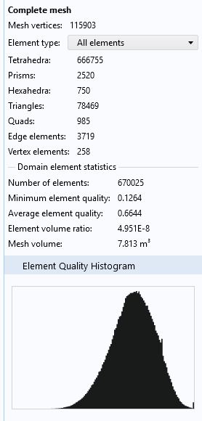

Mesh Plot
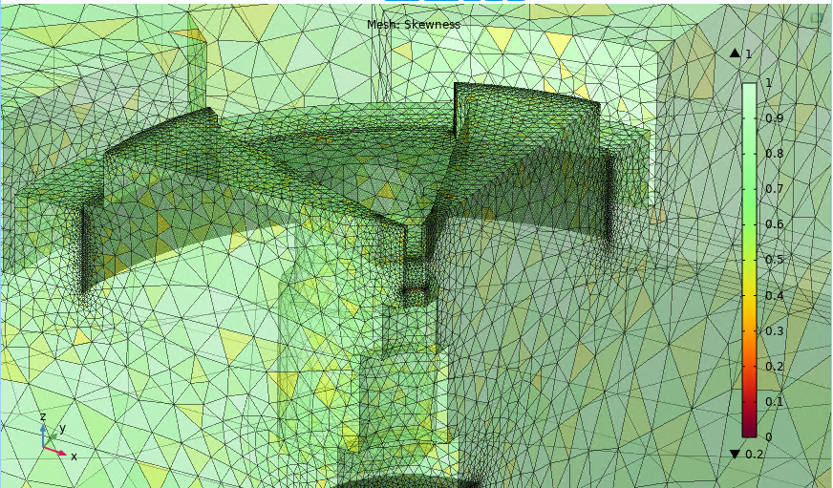

Results
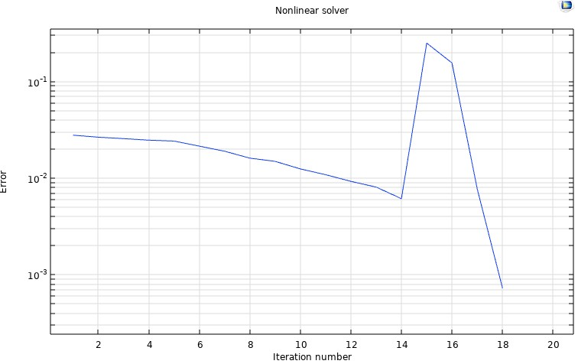

Iteration | Solution estimate norm | Residual norm | Damping factor | Effective step size | residual evaluations | #Jac, | #Sol, | LinIt, | LinErr, | LinRes,
1 | 0.028 | 5.10E+03 | 0.1 | 0.031, | 3, | 1, | 4, | 44, | 0.08, | 0.0002,
2 | 0.027 | 4.80E+03 | 0.1 | 0.029, | 5, | 2, | 8, | 89, | 0.035, | -,
3 | 0.026 | 7.10E+03 | 0.1 | 0.028 7 | 3 | 12 | 197 | 0.12 | -
4 | 0.025 | 1.10E+04 | 0.1 | 0.028 9 | 4 | 16 | 257 | 0.081 | -
5 | 0.024 | 1.00E+04 | 0.0825 | 0.026 11 | 5 | 19 | 285 | 0.1 | -
6 | 0.021 | 9.40E+03 | 0.0738 | 0.023 13 | 6 | 22 | 311 | 0.047 | -
7 | 0.019 | 8.70E+03 | 0.0738 | 0.021 15 | 7 | 26 | 330 | 0.099 | -
8 | 0.016 | 8.10E+03 | 0.0699 | 0.018 17 | 8 | 30 | 349 | 0.058 | -
9 | 0.015 | 7.60E+03 | 0.0699 | 0.016 19 | 9 | 34 | 364 | 0.065 | -
10 | 0.012 | 7.10E+03 | 0.0620 | 0.014 21 | 10 | 38 | 371 | 0.02 | -
11 | 0.011 | 6.60E+03 | 0.0743 | 0.012 23 | 11 | 42 | 377 | 0.012 | -
12 | 0.0093 | 6.10E+03 | 0.0856 | 0.01 25 | 12 | 46 | 383 | 0.011 | -
13 | 0.0081 | 5.60E+03 | 0.0856 | 0.009 27 | 13 | 50 | 389 | 0.011 | -
14 | 0.0061 | 4.40E+03 | 0.2104 | 0.008 29 | 14 | 54 | 395 | 0.026 | -
15 | 0.25 | 1.60E+07 | 1 | 0.19 31 | 15 | 57 | 403 | 0.047 | -
16 | 0.16 | 6.50E+03 | 0.255 | 0.21 32 | 16 | 59 | 447 | 0.11 | 0.00028
17 | 0.0077 | 7.50E+02 | 1 | 0.08 33 | 17 | 62 | 521 | 0.088 | 0.00022
18 | 0.00073 | 1.10E+02 | 1 | 0.013 35 | 18 | 65 | 665 | 0.11 | -

