Files:
extfun_heatcond_q
source.m
thermalcond.m
The above two .m files are put in the directory of matlab, and the .mph file just on the computer desktop.

When open the “extfun_heatcond_q.mph”, I can see the surface plot (under the “Results“ branch) of heat source, conductivity, temperature, which are illustrated in Fig. 1.
(a)
(c)
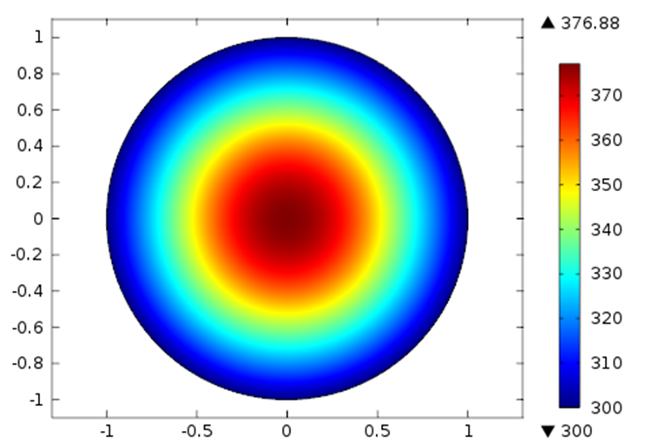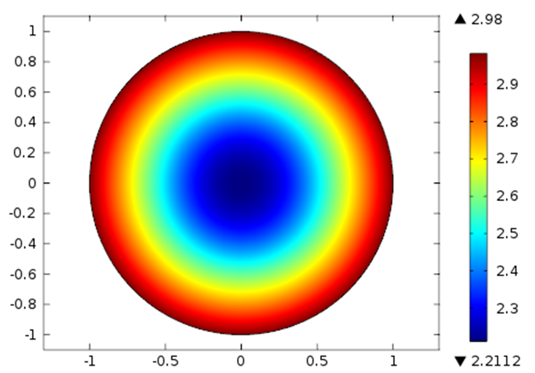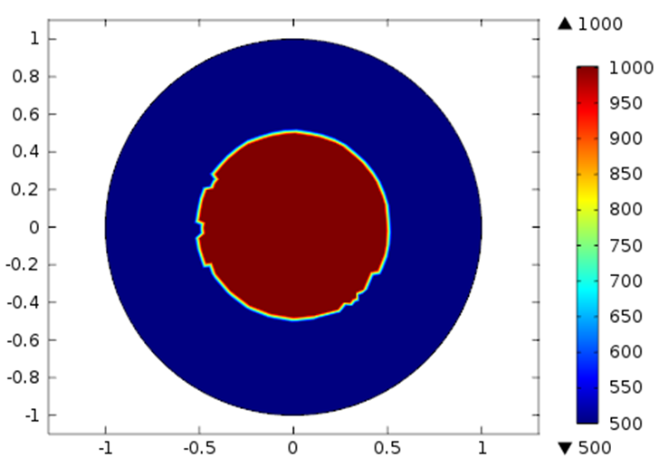
(b)
Fig. 1 the surface plot of temperature (a), conductivity (b) and heat source (c)

I turn to the matlab node (Global Definitions –MATLAB 1), which is an external matlab function and includes thermalcond and source functions.

Question 1: expression in the “Derivatives” term
There is no expression in “Derivatives” term, I wonder when do I must specify the derivatives?

Question 2: convert ElemStructure to int error when plotting
According to the guidance from the documents (new 4.2a edition), the external matlab function can be plotted only in COMSOL (do I misunderstand?). So I add the data ranges (two data sets because there are two arguments in function) in ”plot parameters”. Then I click the “Plot” to plot the function, but fail, and the error “Internal error: cann’t convert ElemStructure to int” occurs, just like Fig. 2.

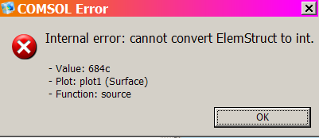
Fig. 2 the ElemStructure to int error

Question 3: about the unit in the material property
I check the model whole with the hope of making it clear. Then I found the thermal conductivity is defined using the external matlab function “thermalcond(T)”. While it shows orange-coloured, and implies “unexcitable unit of input”. The T in the COMSOL model have its inherent unit ‘K’, if using “thermalcond(T[1/K])” instead, the color is black (means no error). The “Heat Souce” in the Heat Transfer model node is similar. Is there any difference between them?
(b)
(a)
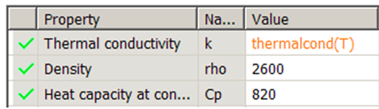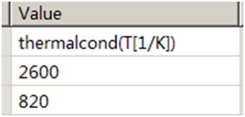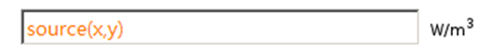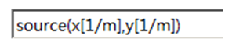
Fig. 3 the unit of input of the function

Question 4: the ElemStructure to int error again when solving

Then, I click “Study” to calculate the model. However, the following problem occurs just similar with the situation when I try to plot the function only before.

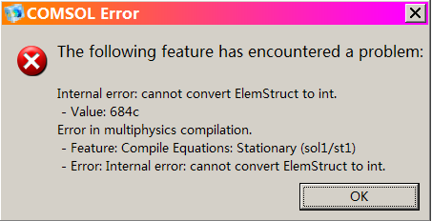
Fig. 3 the ElemStructure to int error

Is There anyone give me some tips and guidance?
Thanks sincerely in advance. Best wishes to you and your family.

FM Huang
Dec.4th.2011

